**Effective Date:** 31 August 2017

**JOB AID: USING THE INTEGRATED SUMMARY FINANCIAL OUTLOOK REPORTING TOOL [FORT]**

**GETTING STARTED**

***\*NOTE: The FinPro database is updated Saturday evening/Sunday morning and after month close. The tool will be unavailable until 2pm on Sundays.***

***To ensure you are using the correct/current version, ALWAYS open/download the template each time you begin reconciliation for a PI. Do not use a locally saved version.***

1. Navigate to the FORT website <http://ebi.emory.edu/FORT>/Integrated.html and download the template. All FORT enhancements are listed/described on the Integrated FORT website.
2. Log into VPN. *We recommend you use the local VPN application on your computer: Big-IP Edge Client.*
3. Open the template. You must enable macros to use the FORT. If you receive the following error messages, select “Enable Content.”



1. Click the “Not Connected” icon on the FinPro FRP tab on the Excel ribbon in the FORT.

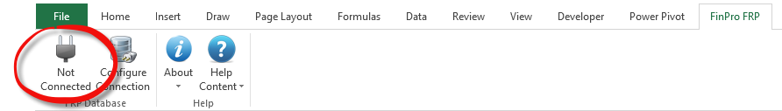

**THE PROJECT SUMMARY**

1. Type (**if you must copy/paste, do so in the formula bar**) the Employee's 7-digit employee ID number.
   1. You must enter any/all 0's that precede the ID. Click “Enter.” Excel will briefly lock while the following occurs: The “Summary” is populated based on the Employee entered.

***\*NOTE: You may notice an Excel “Not Responding” message in the ribbon. It can take time to connect to the database and load the PI data. Be patient; this message does not typically indicate Excel is locked or has stopped functioning.***

1. When you click on the “Hyperlink” to the left of “Project ID,” a worksheet (tab) is inserted into the workbook for the project/activity selected.



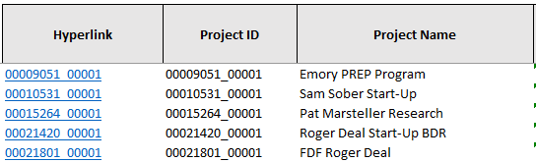

1. Click on the project tab/worksheet that you would like to reconcile or project. To navigate to a particular project or award, use the hyperlinks on the “Summary” worksheet/tab. Activity is incorporated in the Tool; each worksheet represents a combination of the project/activity. The project worksheet will not be created until you select it from the “Summary” worksheet/tab.

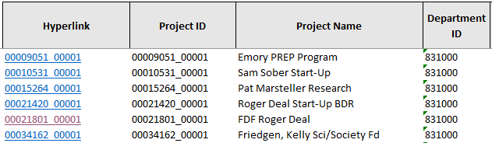

**RECONCILING AND FORECASTING (PROJECTING) EXPENDITURES**

* For instructions specific to reconciling **NonSponsored Projects** please see the [NonSponsored FORT Job Aid](http://ebi.emory.edu/documents/Job%20Aid_Using%20the%20NonSponsored%20FORT%20and%20FAQs_v2.pdf)
* For instructions specific to reconciling **Sponsored Projects** please see the [Sponsored FORT Job Aid](http://ebi.emory.edu/documents/2008%20Job%20Aid%20Using%20the%20Sponsored%20FORT%2008082017%20v8.pdf)

**FAQS**

***Do I have to use VPN to access the FORT if I am working from my Emory University office?***

Even if you are at your desk, you MUST be on the VPN to utilize the FORT. Using the VPN gives you access to the ADMIN core, which is necessary to utilize the (FinPro) database supporting the FORT. You must access the ADMIN core via VPN before you attempt to connect to the FinPro database. We encourage you to use the BIG-IP Edge Client as it provides more consistent VPN access than vpn.emory.edu.

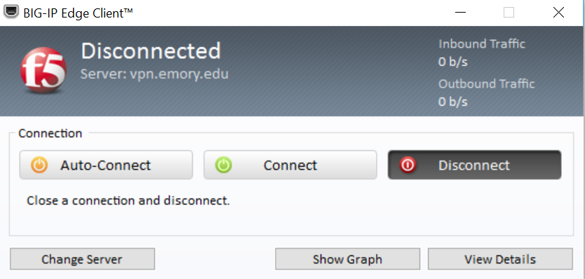

***I have opened the template and the FinPro FRP Ribbon but I do not see the “Connected/Not Connected” button. What do I do?***

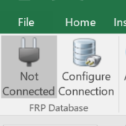If the “Connected/Not Connected” button does not display on the FinPro FRP Ribbon, close the FORT and Excel. Relaunch Excel, click the FinPro FRP Ribbon, and attempt to connect. If the “Connected/Not Connected” button still does not display, submit a Salesforce ticket to the attention of the EBI team. You can access instructions for submitting a FORT ticket on the FORT website: <http://ebi.emory.edu/FORT.html>. You must “Connect” to use the FORT by clicking “Not Connected” to establish a connection to the (FinPro) database to populate the FORT.

***Why isn’t the budget, expense, and encumbrance data displaying on the Project Summary page?***

You must type (do not copy and paste) the EMPLID, Project ID, or Department ID to load the Project Summary.

|  |  |
| --- | --- |
|  | If you have entered a valid ID and still are not able to load details, submit a Salesforce ticket. You can access instructions for submitting a FORT ticket on the FORT website: <http://ebi.emory.edu/FORT.html>. |

***I am forecasting new hires using the Projected Hire 1 – 10 rows. When will the actual hire data appear? Do I need to remove the Projected Hire forecast data that I entered?***

|  |  |
| --- | --- |
| The new hire will appear in the FORT as on as the employee is hired and labor expenditures are processed.  When the new hire appears in the FORT, you must delete the Projected Hire data. |  |

***If I submit an RST, how will that show up on FORT?***

RST’s calculate into the total salary paid to that employee within the month that they have posted to the ledger—just like on the trend report in EBI. Both FORT and the trend report run based on post date (not pay date).

***Do formulas load to the FinPro database?***

No, if you use a formula in a project reconciliation worksheet in the FORT workbook, the result of the calculation will load NOT the formula but it will load the numeric value.

|  |  |
| --- | --- |
| ***How do I clear the template, after I finished the reconciliation/projection and uploaded my FORT?***  Enter zeroes into the ID field with the appropriate number of digits for the selected prompt method (EMPLID = 0000000, Project ID = 00000000, Department ID = 000000). That will clear the data from the template and allow you to enter a new (valid) ID into the tool to begin a new reconciliation/projection.  If you clear the ID field, you may receive an “Invalid Dimension IDs” pop-up. Simply close the pop-up and enter the new ID. |  |

***I have entered the Employee’s ID but NO data has loaded. What do I do?***

Double check that you have connected to the FinPro database. If you are connected but still have this issue, and if you are certain the employee has been assigned responsibility for a non-sponsored project, submit a Salesforce ticket (EBI/FORT). You can access instructions for submitting a FORT ticket on the FORT website: <http://ebi.emory.edu/FORT.html>.

***Some of my non-sponsored projects are not displaying in FORT. Why not?***

Projects will not display until a budget is loaded or actuals (revenues, expenses, or transfers) have posted. The department may not have completed the roles assignment (which is required to allow the data to load into the FORT template when the Employee prompt is used). Submit a Salesforce Ticket (EBI/FORT), if you have roles assignment issues OR if neither of these issues seems to be the reason for your challenge. You can access instructions for submitting a FORT ticket on the FORT website: <http://ebi.emory.edu/FORT.html>.

***Does the FORT include projections for revenues, non-personnel expenses, or transfers?***

You must manually enter the projections for non-salary actuals. Only labor data will project automatically based on percentage earnings for the project period, termination date, or the current fiscal years + 2 additional fiscal years, whichever is sooner.

***Who do I contact if I have additional questions?***

If you are having issues accessing/using the tool, submit a ticket in the Finance Support Center Community Page. Choose “Emory Business Intelligence” for your ticket category. Choose “Financial Outlook Reporting Tool (FORT)” as your ticket subcategory.

***How do I submit a ticket in the Finance Support Center Community Page to request assistance from the EBI team?***

Navigate to <http://online.flipbuilder.com/qsea/hmjm/> for a job aid on “How to Open a Ticket.” Choose “Emory Business Intelligence” for your ticket category. Choose “Financial Outlook Reporting Tool (FORT)” as your ticket subcategory.

